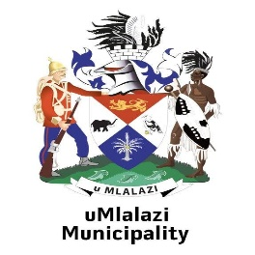 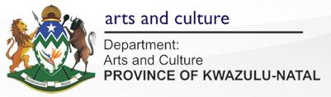

**SUNNYDALE LIBRARY**

**ISAZISO MAYELANA NEMIGOMO EMISHA YOKUVULWA KWAMA-LIBRARY.**

**NOTICE ABOUT NEW RULES OF RE-OPENING OF THE LIBRARIES**.

* ISIKHATHI SOKUVULWA NOKUVALWA KUZOBA 9:00 AM -15:00 PM.
* OPENING AND CLOSING TIMES 9:00 AM 15:00 PM.
* 9:00 AM-10:00 AM ABADALA
* 9:00 AM-10:00 AM ELDERLY LIBRARY USERS.
* 10:00 AM- 15:00 PM UMPHAKATHI WONKANA.
* 10:00 AM -15:00PM ALL USERS.
* AWUVUMELEKILE UKUNGENA UNGASIFAKILE ISIMFONYO.
* NO MASK NO ENTRY.
* KUNGENA ABANGU 10 KUPHELA BEZOSEBENZISA IZINCWADI ZABO KUPHELA.
* ONLY 10 USERS TO BE ALLOWED AT TIME AND USE THEIR OWN STUDY MATERIAL.
* UMA UDINGA UKUBOLEKA INCWADI UTHUMELA I-EMAIL &UCINGO USINIKE IZINSUKU EZIMBILI UKUTHI SIKUCINGELE.
* CIRCULATION OF BOOKS TO BE DONE VIA EMAIL & TELEPHONE, TWO DAYS IN ADVANCE
* ABANTWANA ABANEMINYAKA ENGAPHANSI KWA 13 ABAVUMELEKILE UKUSEBENZISA LIBRARY.
* CHILDREN BELOW THE AGE OF 13 ARE NOT PERMITTED TO USE THE LIBRARY.
* PHOTOCOPY KANYE NOKU PRINTER KUVUMELEKILE NGOKULANDELA IMIGOMO YEZEMPILO.
* PHOTOCOPYING AND PRINTING TO BE DONE OBSERVING HEALTH PROTOCOLS.
* EMAIL- sunnydalelibrary@reservationstwo.com :UCINGO-035 473 3473 / 076 577 2380.
* [EMAIL- sunnydalelibrary@reservationstwo.com](mailto:EMAIL-%20%20sunnydalelibrary@reservationstwo.com): TELEPHONE-035 473 3473 / 076 577 2380.